# Chapter 1: Creating the SAPUI5 application

Please follow the below steps to create the SAPUI5 application that allows the User to enter his first name and last name and click on a “Create” button that inserts the entered input to the table shown.

Steps to develop the SAPUI5 application consists of:

1. **Sign up for a free trial account on SAP Cloud Platform**
2. ***Creating the SAPUI5 project in SAP Webide***
3. ***Develop the User Interface (UI) for the application***
4. ***Deploy to HANA Cloud Platform for testing the application***

**1. Sign up for a free trial account on SAP Cloud Platform**

***Step 1: Log into the SAP website:***

*At the upper-right corner of this tutorial page (or any page on www.sap.com), click the Log On icon. If you have an account on www.sap.com (e.g. an S, C, D or I number) you can enter it or the associated email along with your password.*

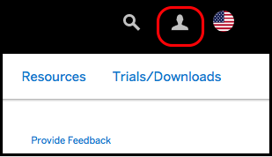

*If you don’t have an account yet, you can select one of the other login methods or click Register to create an account.*

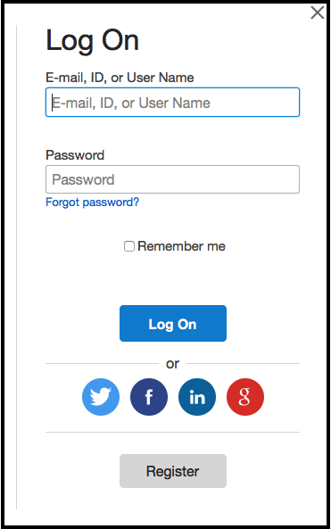

***Step 2: Register at sap.com***

*If you clicked Register in the previous step, you will see a Register dialog. Fill in the required fields, and click Register.*

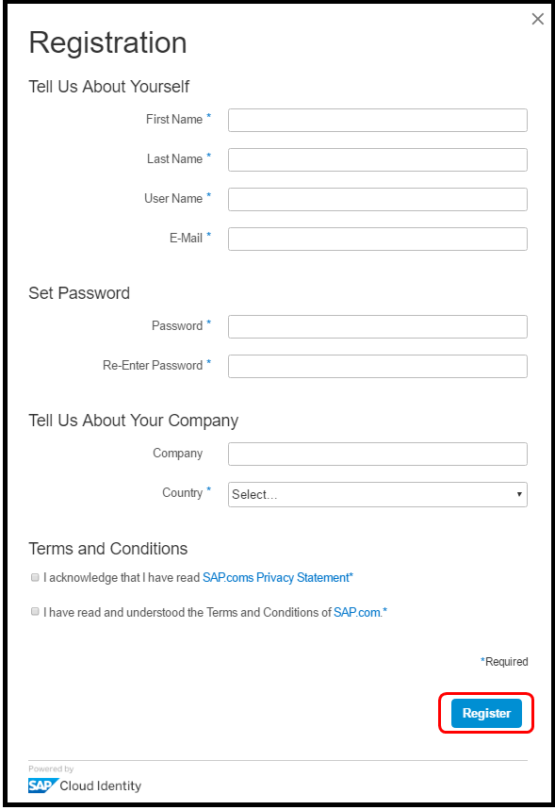

*You will get a message that an activation link has been sent to you.*

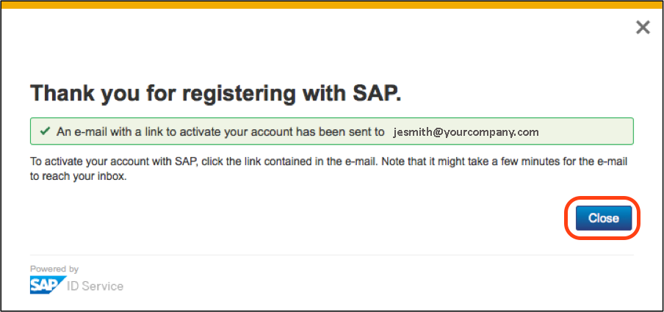

***Step 3: Activate your account:***

*Once again in the upper-right corner of this tutorial page (or any page on www.sap.com) click on the Log On button.*

*Enter the same credentials you used to log into the SAP.com website*

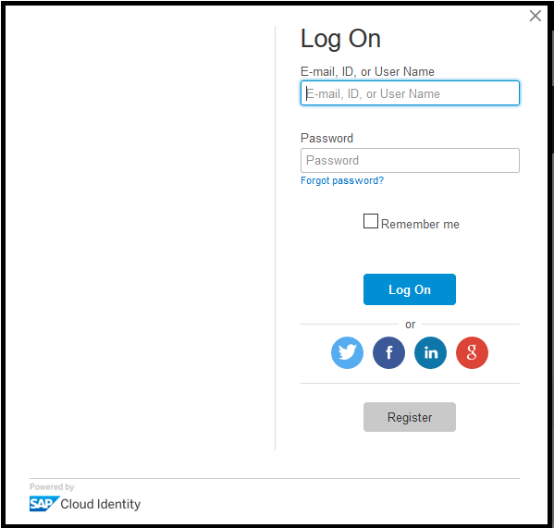

*If you have just registered in the step above you may get a log-in error until you activate your account via the email link sent.*

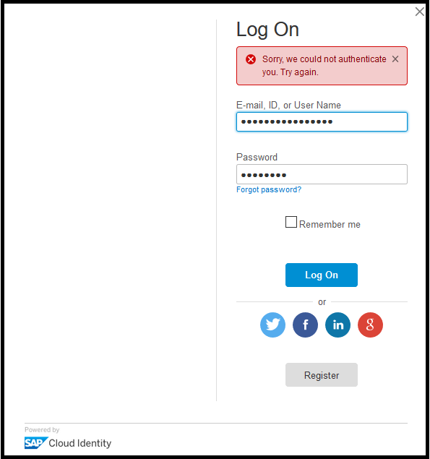

After activating your account, you will see the following screen. Click continue.

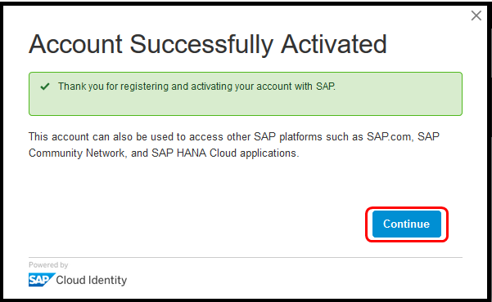

***Step 4: Add the SAP.com registration to your SAP Cloud Identity account:-***

*After activation, or if you already had an SAP account, go to the SAP Cloud Platform Trial (https://account.hanatrial.ondemand.com/) page and click on the Log On button.*

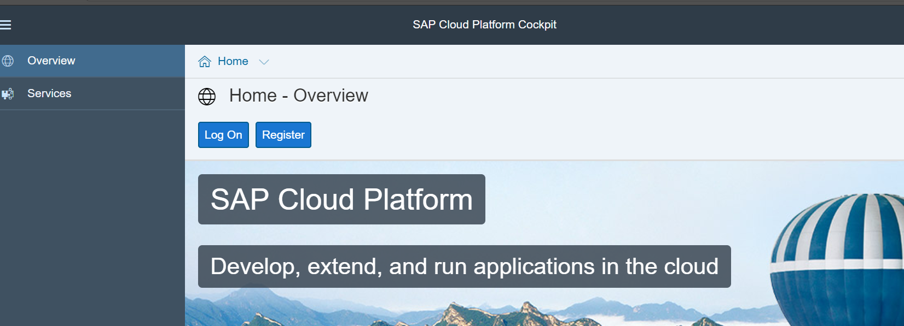

*Assuming you don’t already have a SAP Cloud Platform trial account, you will see an Upgrade your account for SAP.com dialog. If so, fill out all fields and click Register. This simply adds the SAP.com registration to your login account on SAP Cloud Identity. There is no cost associated with this registration*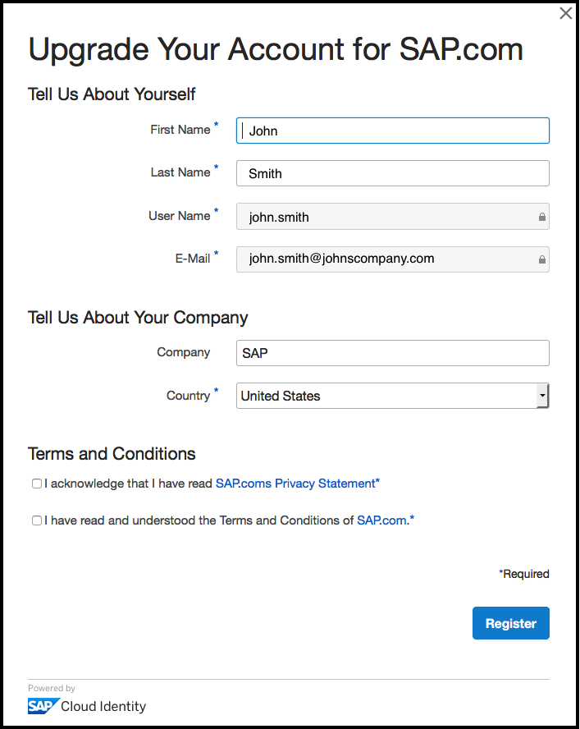

***Step 5: SAP Cloud Platform cockpit:***

*Once you have accepted the Terms and Conditions and registered, the SAP Cloud Platform cockpit will load.*

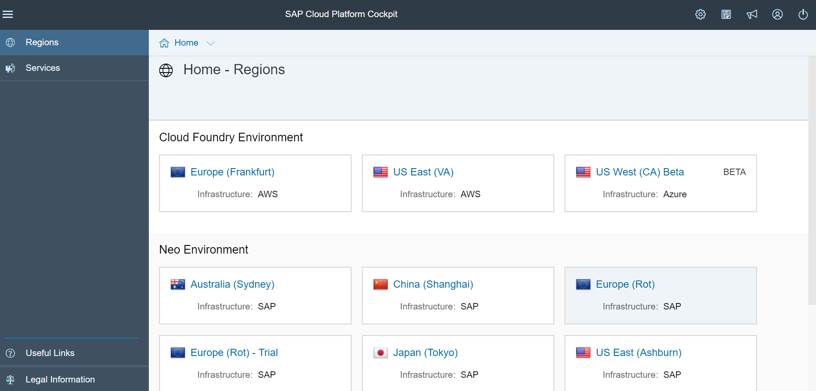

**2. Creating the SAPUI5 project in SAP Webide**

***Step 1: Launch the SAP Web IDE***

*Click on the Europe(Rot)-Trial tile under Neo-Environment section of your SAP Cloud Platform cockpit.*

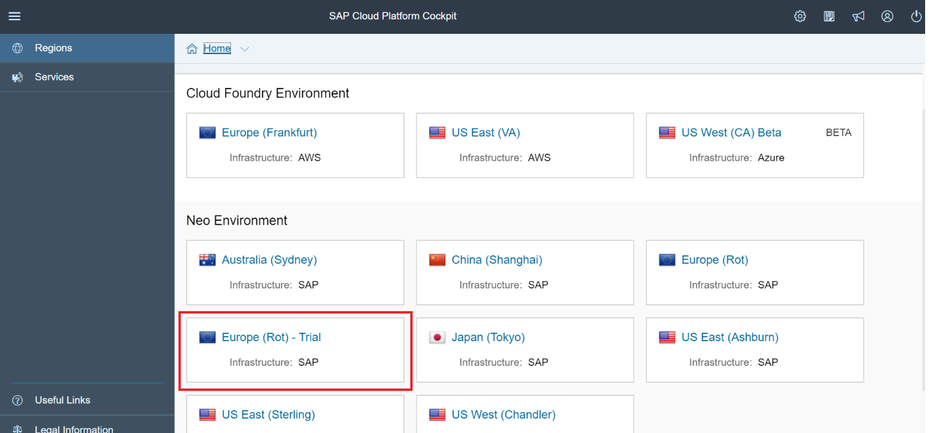

*Select your Personal Trial Account by clicking on <…>trial as shown below*

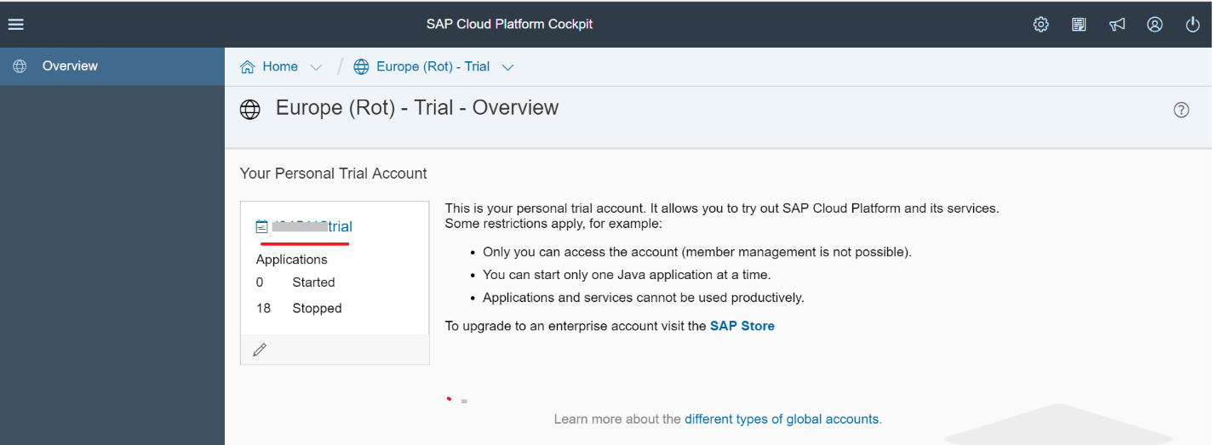

*Click on the Services tab of your SAP Cloud Platform cockpit. Click the SAP Web IDE link in the DevOps category.*

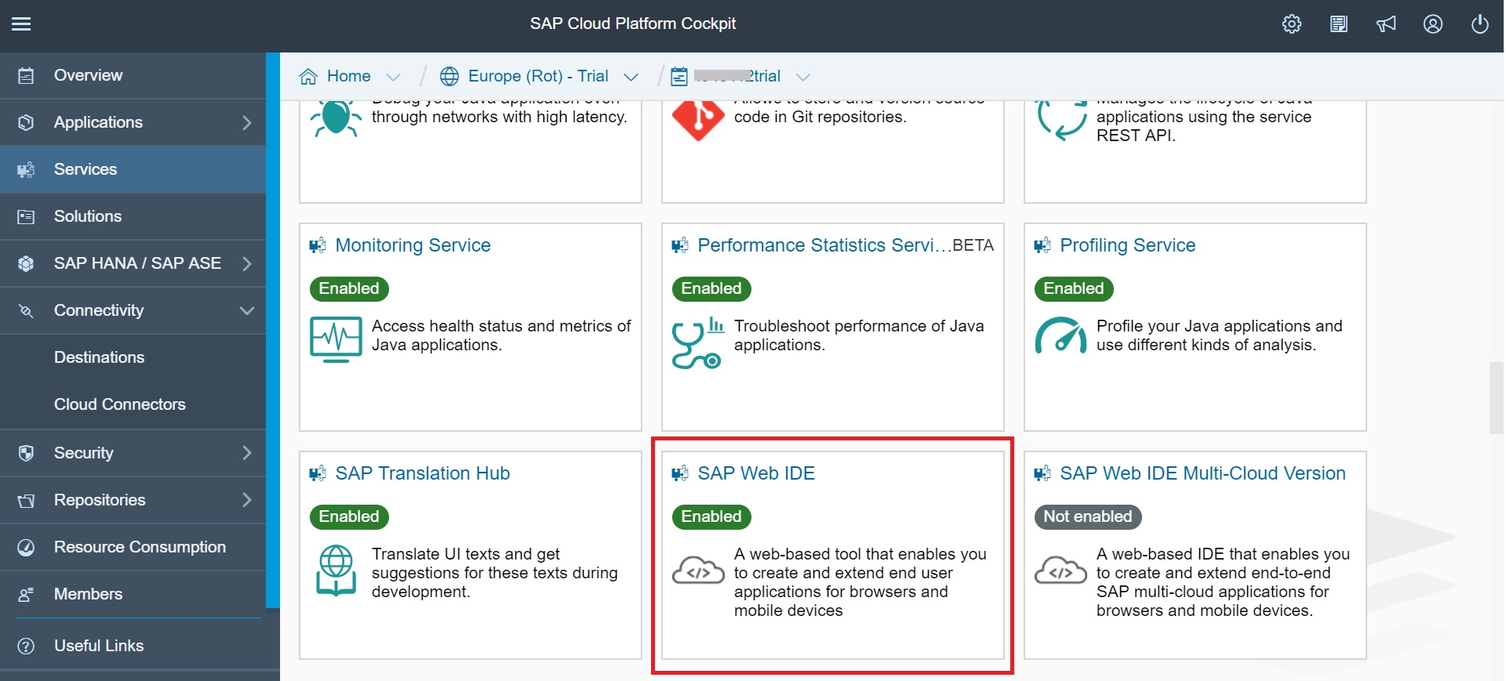

*Click the ‘Go to Service’ link to launch the Web IDE in a new tab.*

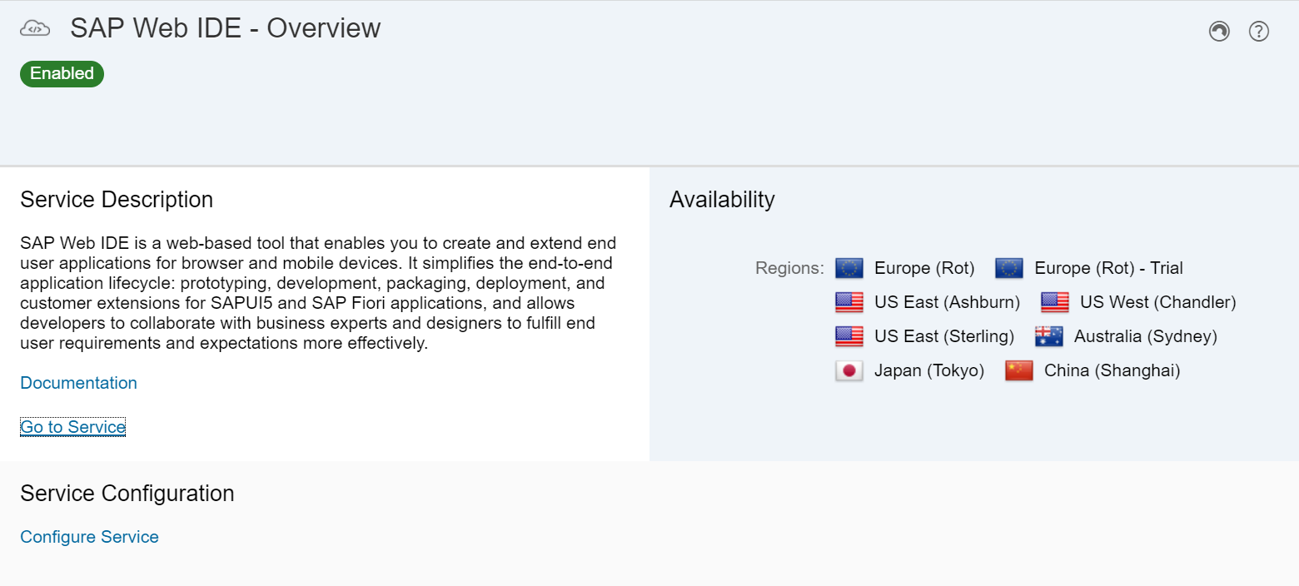

*The SAP Web IDE opens (this may take a few seconds).*

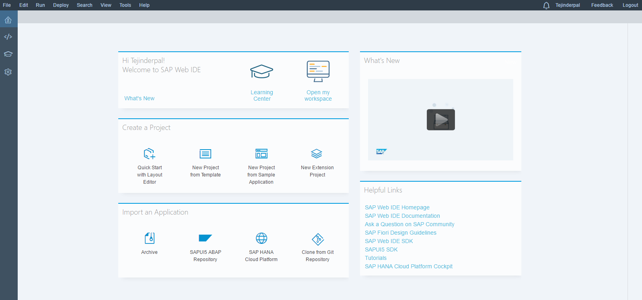

*From the left side bar click the*  *icon to open the Development environment.*

***Step2: Generate an Application from Template:***

*From the Project Explorer select the Workspace root folder. Right click and select New > Project from Template*

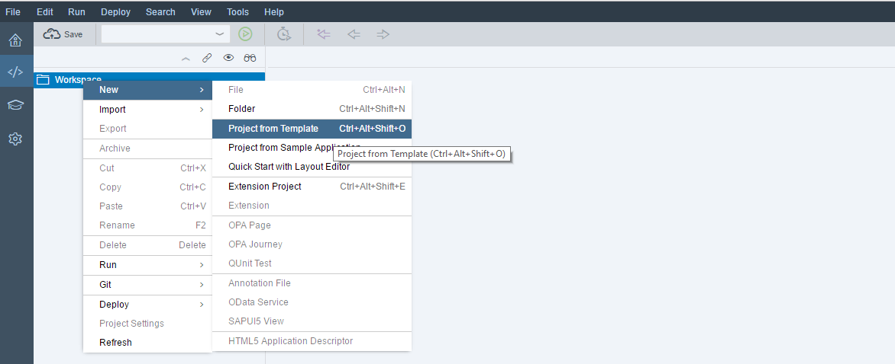

*The new project from template wizard is opened. From the drop down select the All Categories tab as this will list all the types of application you can build.*

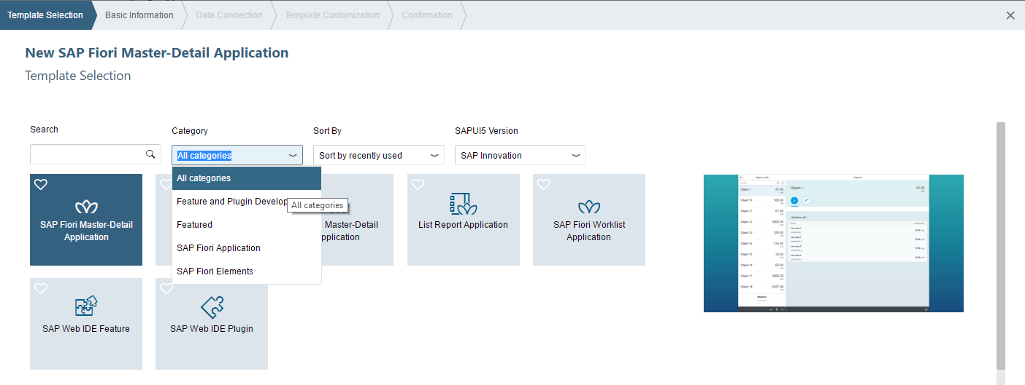

*In the Template Selection screen select the SAP UI5 Application template as shown in below figure.*

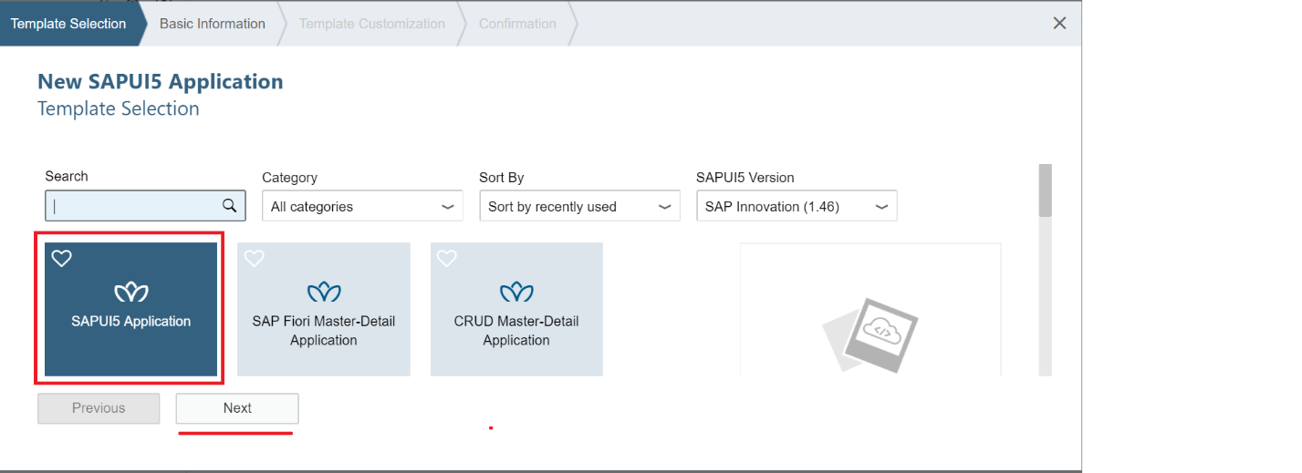

*Click Next the Basic Information screen opens. Enter the Project Name* – **personslist** *and**click on Next.*

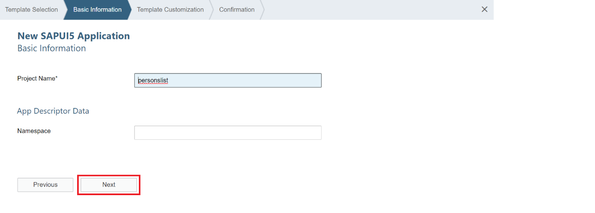

*This opens the Template customization screen, click on Finish*

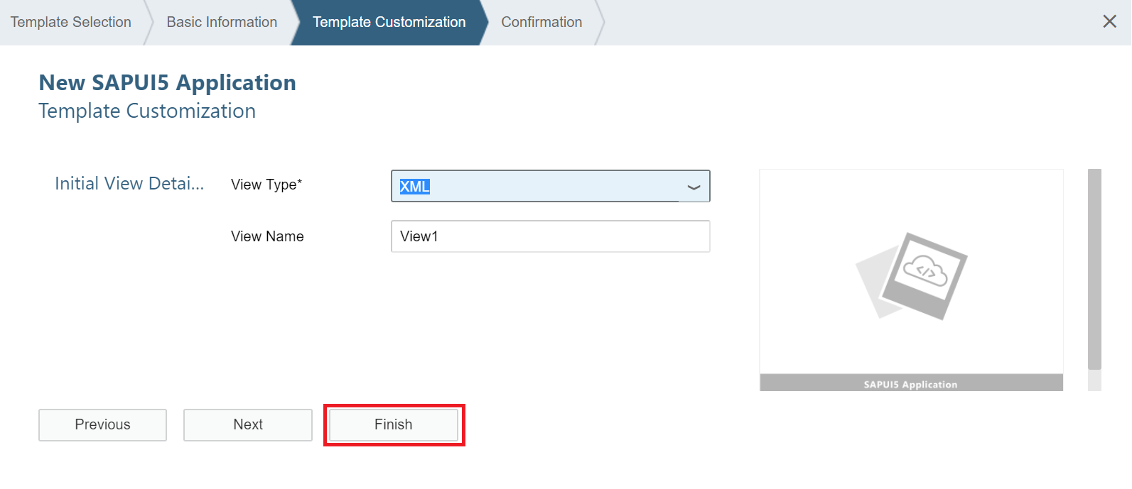

**3. Develop the User Interface (UI) for the application**

***Step1:- Create view and controller code:***

*Double click on the “view1.view.xml” file from personslist project under workspace. This will open up the file in the editor.*

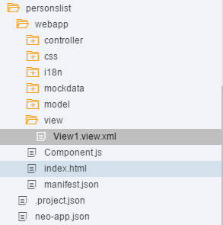

*Add the following code to the xml file* ***(delete the initial code)*** *this will result in the following code in the “view1.view.xml” file as shown in the snapshot.*



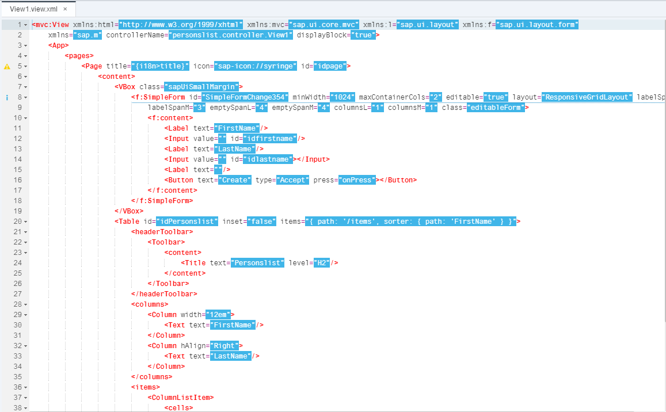

*Press “Ctrl + S” to save your changes.*

*Open the “view1.controller.js” file from personslist project under workspace. This opens the file contents in the editor. Copy and replace the contents of the file with the below code and save it.*



*this will result in the following code in the “view1.controller.js” file as shown in the snapshot.*

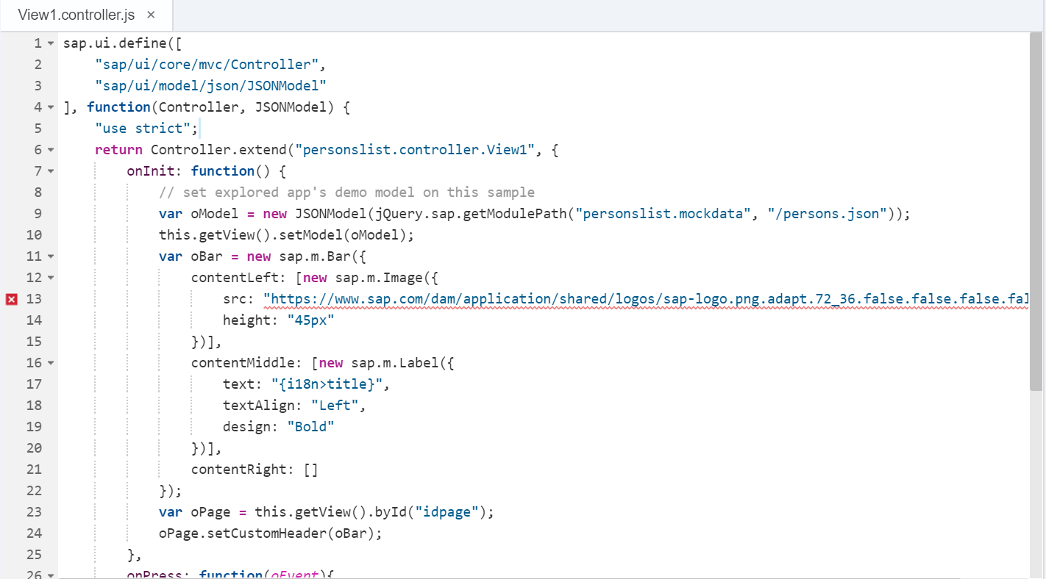

*Create a folder called mockdata under* **“webapp”** *folder under that create a file called “persons.json”.*

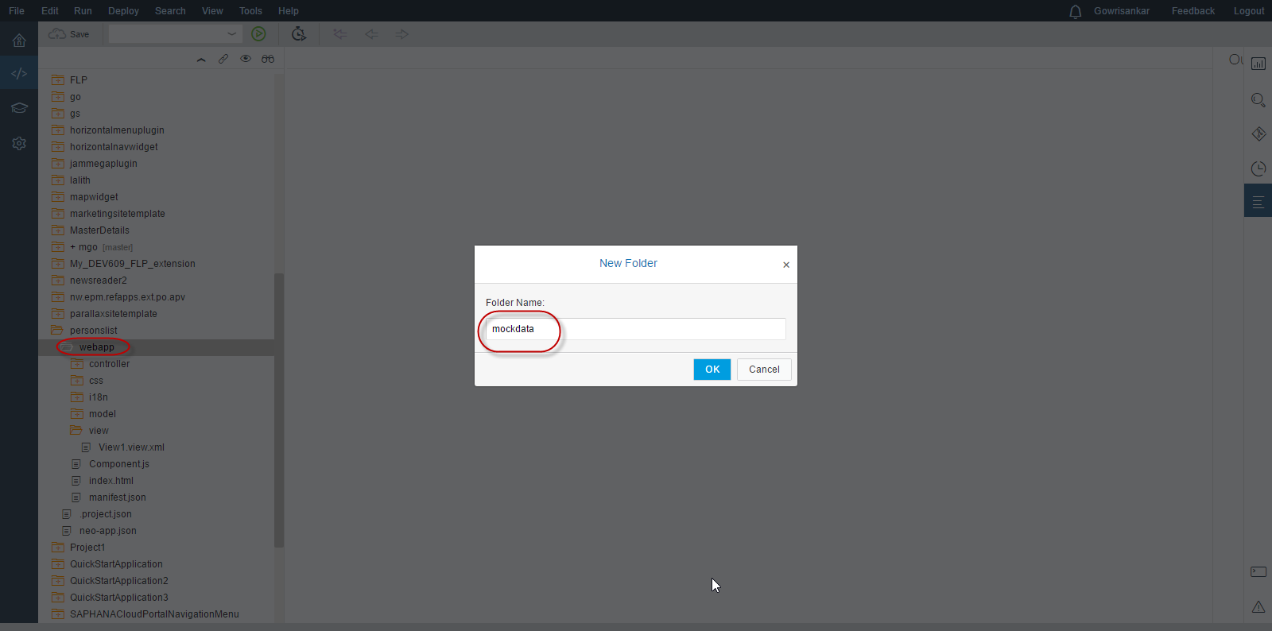

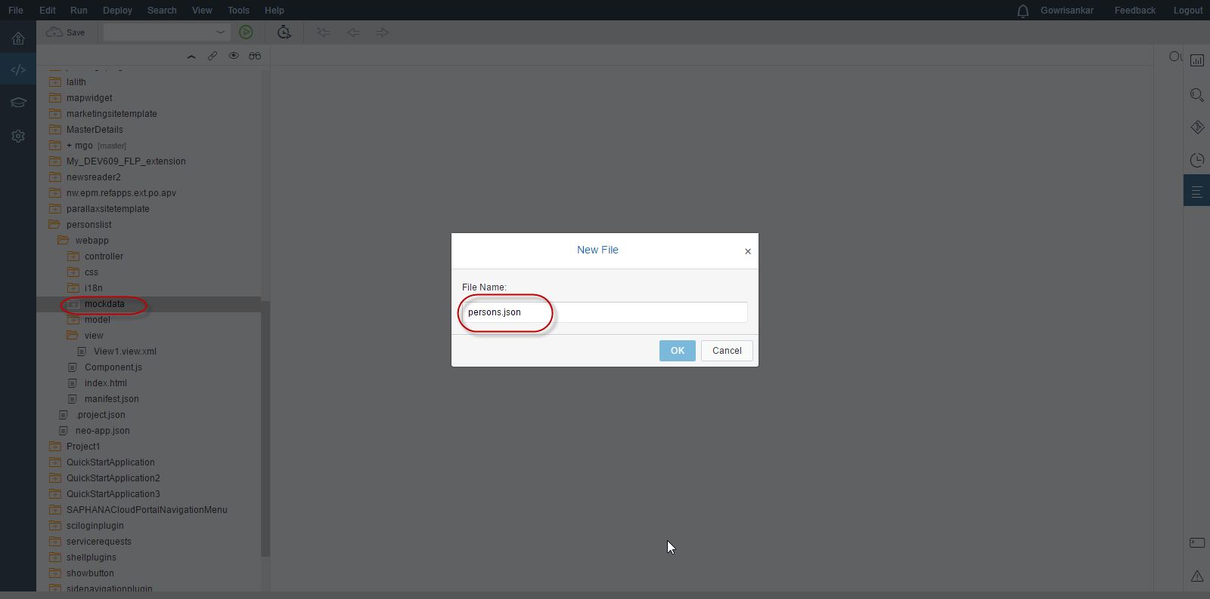

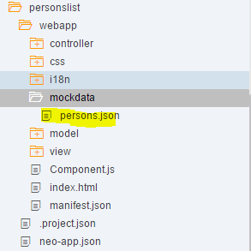

*Add the following code to the “persons.json” file.* *Press “Ctrl + S” to save your changes.*

**{**

**"items" : [{**

**"LastName": "Dente",**

**"FirstName": "Al"**

**}, {**

**"LastName": "Friese",**

**"FirstName": "Andy"**

**}, {**

**"LastName": "Mann",**

**"FirstName": "Anita"**

**}, {**

**"LastName": "Schutt",**

**"FirstName": "Doris"**

**}, {**

**"LastName": "Turner",**

**"FirstName": "Paige"**

**}]**

**}**

1. **Deploy to SAP Cloud Platform for testing the application**

*In the workspace, right-click the project and choose* Start of the navigation path **Deploy** Next navigation step **Deploy to SAP Cloud Platform** End of the navigation path

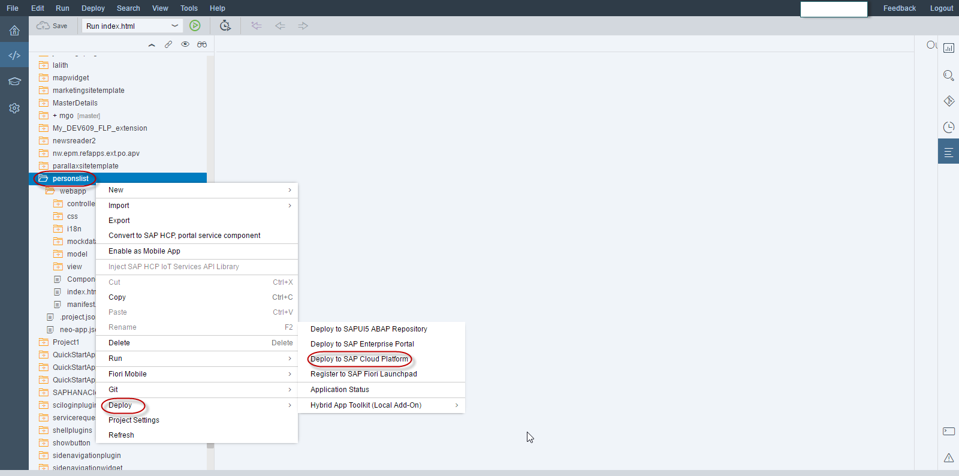

*Enter the application name and click on deploy to deploy the application on SAP cloud platform*

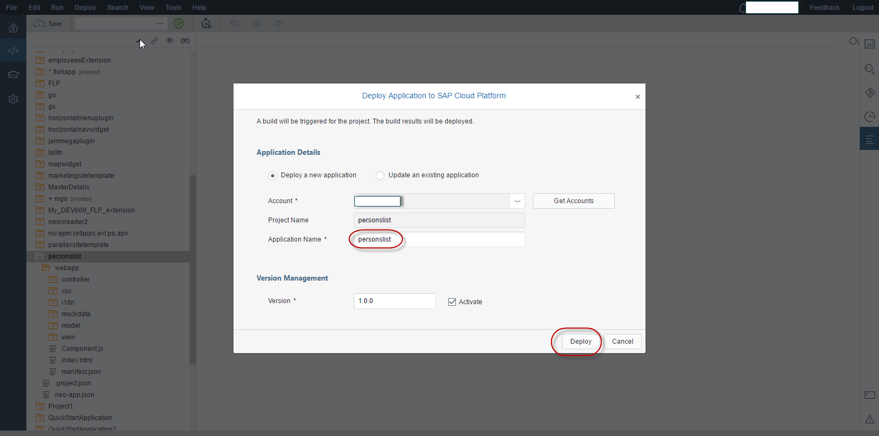

*Click on the link “Open the active version of the application” to open the application.*

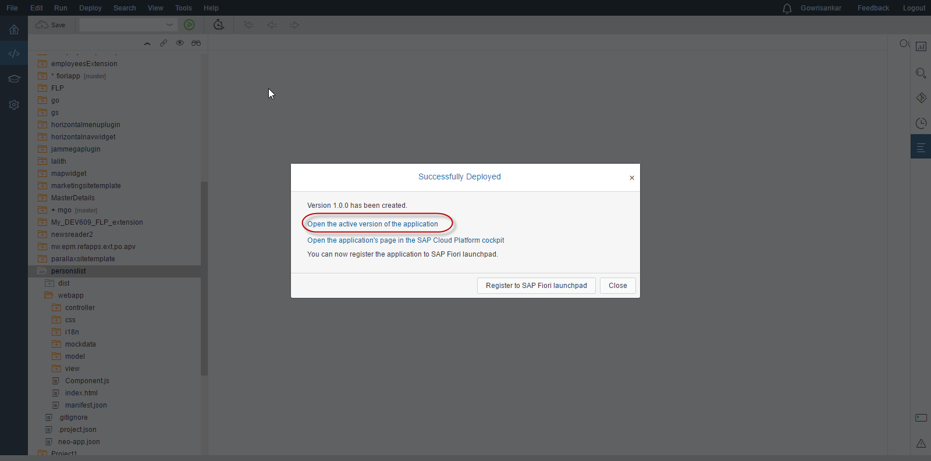

Please check your SAPUI5 application that allows the User to enter his first name and last name and click on a “Add” button that inserts the entered input to the table shown.

